Trade of Metal Fabrication
Module 2: | Thermal Processes
Unit 1: | Introduction to the Oxy/Fuel Cutting, Freehand/Attachments
 | Phase 2

Table of Contents
List of Figures 5
List of Tables 6
Document Release History 7
Module 2 – Thermal Processes 8
Unit 1 – Introduction to the Oxy/Fuel Cutting, Freehand/Attachments 8
Learning Outcome: 8
Key Learning Points: 8
Training Resources: 9
Key Learning Points Code: 9
Operating Techniques 10
Gas Characteristics 11
Safety in Cylinder Handling 13
Safe Transport of Cylinders 15
Safe Storage of Cylinders 15
Gas Cylinders 16
Safe Storage of Gas Cylinders 17
Safe Storage of Gas Cylinders 18
New Industrial Cylinder Identification Chart 22
Equipment Assembly 23
Portable Oxy-Acetylene Welding and Cutting Equipment Assembly 23
The Oxy-Acetylene Flame 24
Welding Demonstration 2 - The Structure of the Oxy-Acetylene Flame 25
Flame Cutting Procedure 26
Operations Involved in Cutting 26
Oxy-Fuel Gas Cutting by Hand 28
Oxy-Fuel Gas Cutting by Machine 29
Profile Machine 30
Cutting Nozzles 33
Circle-Cutting Device 34
Attachments 35
Spade Guide 35
Small Circle Guide 35
Radius Bar 36
Bevel Guide 36
Cutting Techniques 37
General 37
Thick Material 37
Painted and Galvanised Material 37
Flame Cutting 38
The Process 38
Calculations for Straight Circular and Irregular Cuts 40
The Pre-Heating Flame 40
Natural Gas 40
Types of Cut 41
Correct Cutting 41
Cutting Speed Too Slow 41
Cutting Speed Too Fast 41
Self Assessment 42
Questions on Background Notes – Module 2.Unit 1 42
Answers to Questions 1-10. Module 2. Unit 1 45
Index 49

List of Figures
Figure 1 - Operating Techniques 10
Figure 2 - Mechanised System 10
Figure 3 - Portable Oxy-Acetylene Welding and Cutting Equipment Assembly 24
Figure 4 - Oxy-Acetylene Flame Showing the Various Zones 25
Figure 5 - Neutral Flame Cone Tip Hottest Part Approx. 3100°C 26
Figure 6 - Carburising Flame 26
Figure 7 - Oxidising Flame 26
Figure 8 - Drag Lines on Cut Plate 27
Figure 9 - Some tips for achieving a good cut 29
Figure 10 - Oxy-fuel Gas Cutting Freehand 30
Figure 11 - Stack Cutting 30
Figure 12 - Typical Straight-Line and Circle-Cutting Machine 31
Figure 13 - Flame-cutting Procedure 32
Figure 14 - Cutting Nozzle Design Feature 34
Figure 15 - Spade Guide 36
Figure 16 - Small Circle Guide 36
Figure 17 - Radius Bar 37
Figure 18 - Bevel Guide 37
Figure 19 - Cutting Techniques 38
Figure 20 - The Action of Oxygen Cutting 40

List of Tables
Table 1 - Examination of Flame-Cut Edges 28
Table 2 - Approximate Pressures for Hand Cutting Steel Plate 33

Document Release History
Date | Version | Comments
16/10/06 | First draft
04/12/06 | Implemented edits from Kenny
13/12/13 | SOLAS transfer

Module 2 – Thermal Processes

Unit 1 – Introduction to the Oxy/Fuel Cutting, Freehand/Attachments
Duration – 14 Hours

Learning Outcome:
By the end of this unit each apprentice will be able to:
- Assemble Oxy/Fuel cutting equipment
- Adjust pressure regulators to correct settings
- Light and adjust correct cutting flame and shut down equipment safely
- Fit and use cutting attachments - straight line - bevel - radius bar (trammel) - small guide
- State safety standards and precautions when using oxy/fuel equipment
- Preheat mild steel plate for cutting
- Cut mild steel plate freehand and with attachments

Key Learning Points:
Rk | Correct storage of full, empty and in use cylinders.
Sk | Assembly of equipment and maintenance.
Rk Sk | Gas pressures and their regulation.
Sk | Lighting and adjusting cutting flame - correct torch height and speed of travel.
Sk M | Cutting technique - cutting data - cutting speeds.
Rk | Cutting torch design.
Sc Sk Rk | Cutting process - types of cut – preheating.
H Rk | Safety standards, precautions and their application.
H Rk | Hazards identification.
Rk | Identification and use of various attachments - circular and straight line.
Rk | Types of cutting torches and nozzles.
Rk | Types of industrial gases used for metal cutting.
M | Calculations for straight, circular and irregular cuts.
P | Communication, Work planning, Safety awareness.

Training Resources:
Fabrication workshop facilities, safe working area, Oxy/Fuel cutting equipment and attachment - safety clothing and equipment.
Handout on cutting data, lecture, materials.

Key Learning Points Code:
M = Maths D= Drawing RK = Related Knowledge Sc = Science
P = Personal Skills Sk = Skill H = Hazards

Operating Techniques
Mechanised cutting produces a superior finish to manual operation.
A variety of mechanised traversing systems are available or the torch can be moved along a straight line or by hand to produce a complex shape.

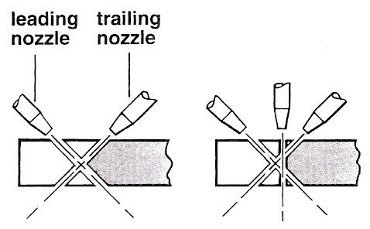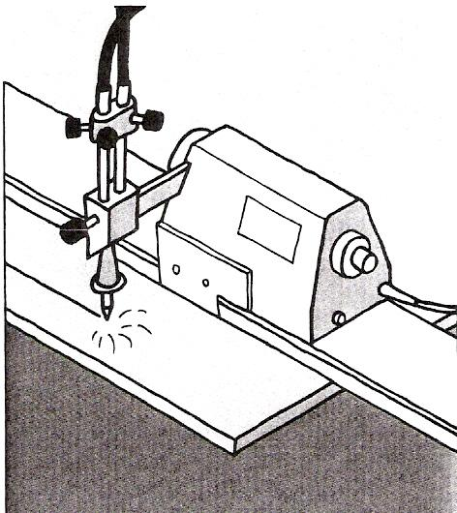
Figure 1 - Operating Techniques

Mechanised systems can be used to prepare the edges of plate prior to welding.

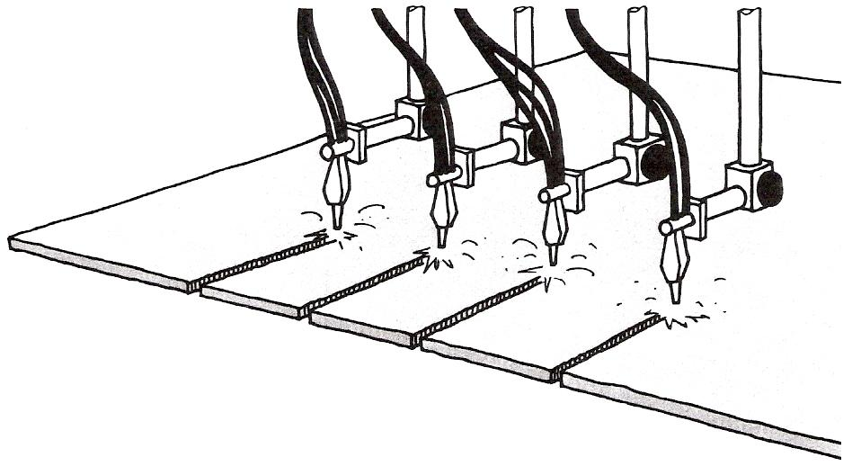
Figure 2 - Mechanised System

More than one cut can be made at the same time.

Gas Characteristics
All operators and users of gases in cylinders must fully understand the potential hazards and properties of the gases they are using and are stored on site.
Each gas has its own characteristics, which affect its behaviour. Gases also change characteristics when subjected to external pressures.
An important characteristic of a gas is its density relative to air because this will determine whether it rises or falls if it leaks. The table below gives the densities of some common gases.
Most gases are colourless and odourless in their natural state so there is little or no warning of a leak. Most fuel gases have or are given a "smell" to aid leak detection.
All suppliers have a complete range of material safety data sheets which detail the chemical and physical properties of the gases as well as their characteristics. In addition suppliers can provide advice on safe handling, storage, transport and use of the product.

IMPORTANT:
Know ALL the properties of the gases you deal with!

This publication outlines the basic properties and characteristics of commonly used industrial gases. We strongly advise you to supplement this information with appropriate material safety data sheets.

Gas density compared to air (approximately)
Hydrogen 0.06
Helium 0.1
Nitrogen 0.9
Acetylene 0.9
Air 1
Oxygen 1.1
Argon 1.4
Carbon dioxide 1.5
Propane 1.5
Industrial gases are categorised as follows:

Oxidants | These do not themselves burn but support combustion. By increasing the amount and type of oxidant many things will burn that are not normally flammable.  examples: Air and oxygen
Inerts | These do not generally react with other materials, they do not support combustion nor do they support life. Inert gases should be regarded as asphyxiants because if they leak they displace air and hence the oxygen in the atmosphere.  examples: Nitrogen, Argoshield and helium based mixtures
Flammables | These gases when mixed with an oxidant and provided with the right ignition source will burn. An increase in the temperature of the fuel/oxidant mix can also cause ignition.  examples: Acetylene, hydrogen and propane
Toxics | These have the potential to cause injury or threaten life, even in small concentrations.  examples: Carbon monoxide, chlorine and ammonia
Corrosives | These react chemically with other materials causing reactions and deterioration. Toxic gases may be given off.  examples: Chlorine and sulphur dioxide
Pyrophorics | Will ignite spontaneously in contact with air.  examples: Silane and phosphine

Safety in Cylinder Handling
A typical gas cylinder is about 1.6m (5 ft.) tall, 200mm (8 inch) diameter base and weighs over 69kg (150 lbs). If it falls, anyone in its way will get hurt.
The dimensions of cylinders vary according to their contents. Free-standing cylinders should be regarded as unstable!
The correct way to move cylinders is with the cylinder:
- upright
- secure
- valves uppermost

REMEMBER! Never attempt to catch a falling cylinder - get out of the way!

Anyone moving cylinders should always wear protective footwear, clean gloves and eye protection.
It is obviously better to move cylinders using mechanical aids, for example a trolley or on a cylinder pallet with a forklift truck. The Manual Handling Operations Regulations 1992 require that wherever possible operations are mechanised or handling aids provided.

Where this is not reasonably practicable then assess the handling task, including:
- can the task involved be mechanically aided, does it need more than one person?
- the weight, height and nature of the loads to be moved
- the environment; for example lighting, flooring, temperature access
- the individual's ability to move and maintain control of the load
REMEMBER:
A cylinder is never empty.

The correct way to move cylinders over long distances or uneven ground is with the aid of a purpose designed trolley complete with some means of retaining the cylinders.
Cylinders must never be left free standing, they must always be secured or under somebody's direct control. Be aware of the hazards of manually lifting cylinders from horizontal to vertical. Make sure all personnel have attended a specific manual handling course.
Cylinders must never be rolled along the ground as damage may occur to the identification of the cylinder and to the cylinder valve. It can be extremely dangerous to roll steel cylinders full of gas across concrete.
Never transport cylinders with the pressure regulator and equipment attached. Cylinders must not be moved with the valve open.
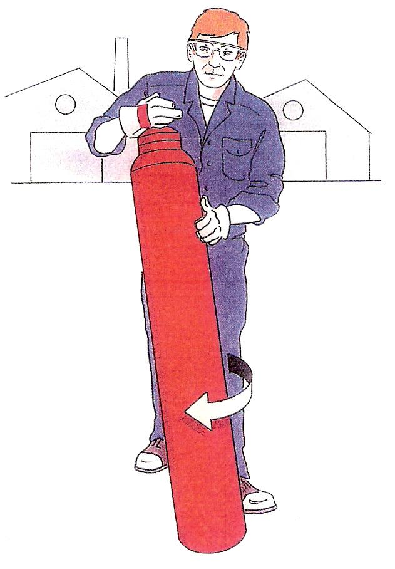

Safe Transport of Cylinders
- If possible carry cylinders in open vehicles or open trailers.
- If cylinders must be carried in closed vans or cars, ensure good ventilation.
- All cylinders are checked by BOC Gases after filling for leak tightness. However after loading the cylinder into your vehicle check again that there is no leakage of gas.
- Secure cylinders properly and ensure they do not project beyond the sides or end of the vehicle.
- Unload the cylinders as soon as possible and move them to a secure and well ventilated storage area.
- Do not smoke while carrying cylinders containing oxygen or flammable gases (e.g. acetylene, hydrogen, propane) inside vans or cars.
- If at any time a cylinder is leaking, park your vehicle in a safe place and contact BOC Gases for advice.
- If you are involved in a road accident advise the emergency services that gas cylinders are being carried.
- If in doubt on any point ask for guidance before leaving the BOC Gases site.

Safe Storage of Cylinders
- It is best to store compressed gas cylinders in the open, in a security fenced compound, but with some weather protection.
- Within the storage area oxygen cylinders should be stored well away from fuel gases i.e. dissolved acetylene, LPG, hydrogen etc.
- Full cylinders should be stored separately from the empties and empty oxygen cylinders should be segregated from empty fuel gas cylinders.
- Other products should not be stored in the gas storage area, particularly oil or corrosive liquids.
- It is best to store all cylinders upright, taking steps to see that they are secured to prevent them falling.
- Acetylene and propane must never be stacked horizontally in storage or in use.
- Your storage arrangement should ensure adequate turnaround of stock.

Gas Cylinders
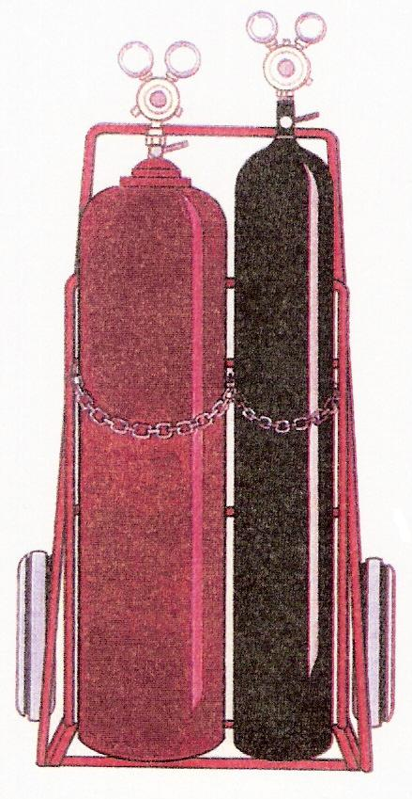
When faced with an industrial gas cylinder full of gas and asked, "What makes the cylinder potentially hazardous?” the average person is likely to mention:
- the size and weight of the cylinder
- they can fall over
- the gas inside the cylinder

Most people would not think to add:
- the pressure of the gas in the cylinder

But the pressure of the gas in the cylinder is potentially the greatest hazard of those listed above (with the exception of some special gases).
Many gases are considered harmless at normal atmospheric pressure and temperature. However, if they are subjected to high pressure or temperature changes they are potentially hazardous.
A good example is air; it is perfectly safe until pressurised, when its stored energy can make it hazardous.
Cylinders used for storing gases under pressure are designed and built to a high specification and are subjected to regular pressure tests.
The supplier of the gas in the cylinder has a legal duty under the Pressure Systems and Transportable Gas Containers Regulations 1989 to inspect and test the cylinder regularly.

How often the cylinder needs to be tested will depend on:
- the gas contained in the cylinder
  - fuel gas cylinders are tested more frequently than compressed air cylinders for example.
- the working pressure the cylinder is subjected to
  - different gases are stored at different pressures.

Always ensure cylinders are upright and secure.

The supplier can establish when the cylinder is due for test from stampings on the neck of the cylinder and by using shaped and coloured "test rings" fitted around the neck of the cylinder. Each colour and shape of test ring will determine in which year the test is to be carried out. This test ring is for the suppliers use and need not concern the user of the cylinder.

Cylinders are filled to different pressures dependent on the characteristics of the gas and the capability of the cylinder. They are made of steel or aluminium alloys. All cylinders are manufactured to meet European and British Standards and/or Home Office Specifications.

Although some cylinders are welded most are solid drawn from a single steel billet. This gives them strength and robustness. In addition some cylinders have a bursting disc to vent the gas quickly and reduce pressure should the cylinder be subjected to heat for example.

Most cylinders do not have a bursting disc. If the pressure increases abnormally, the cylinder normally splits or peels open to release its contents rather than fragmenting. However, it does depend on circumstances and the reasons for failure.

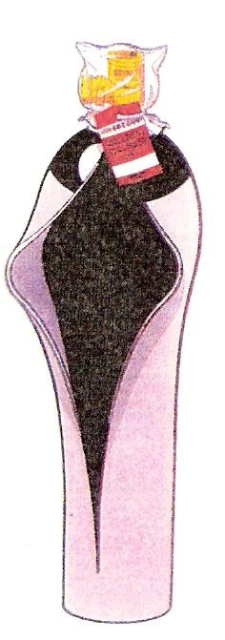

Safe Storage of Gas Cylinders
There are various British Compressed Gases Association (BCGA) Codes of Practice and Health and Safety Executive (HSE) guidelines for the storage of different gases. For industrial gases refer to BCGA Guidance Note GN2 which provides guidance on the hazards of storing gas cylinders and good practice for the controlling of risks.

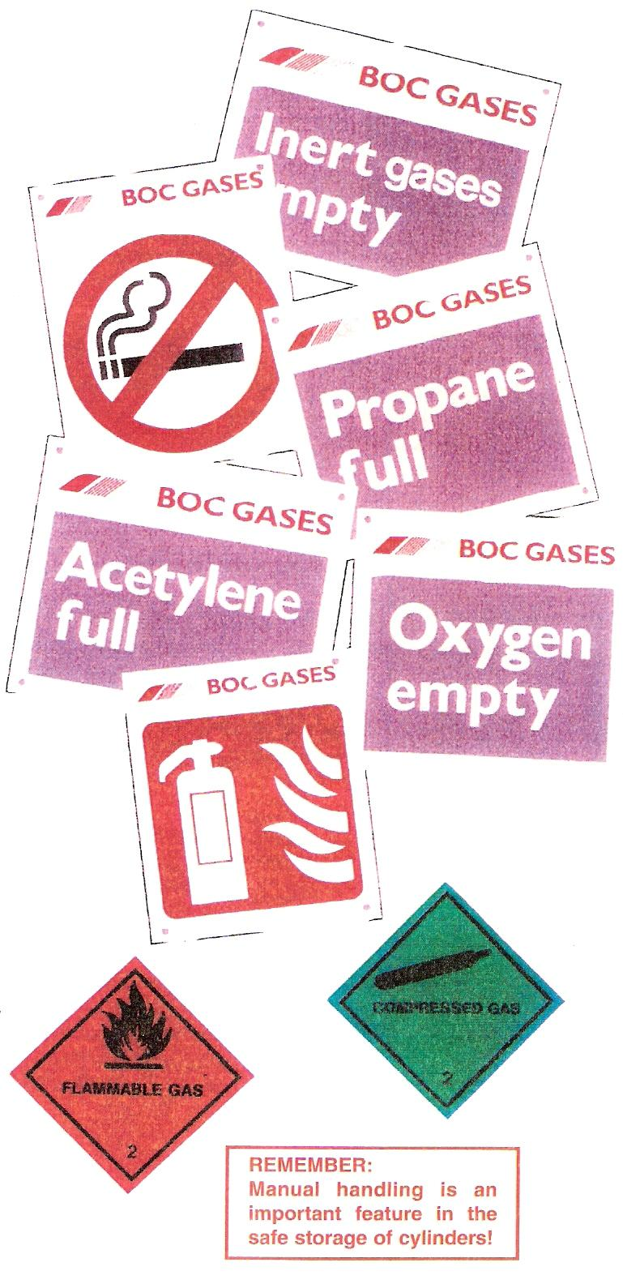
Every storage situation should be considered on its merits therefore risk assessments should be carried out for each storage location. The following notes may be used as a basic guide; however special circumstances may necessitate variations on these recommendations.

In the event of an incident the fire brigade will arrive on site and expect to receive information from the site fire marshal (safety officer etc.) on the type and number of cylinders as well as their location. If this information is not available no-one may enter the premises.

You must set emergency procedures for each storage location. For large storage areas, consult the emergency services.

There are a number of issues to be considered when storing cylinders:
- the nature of the gases stored
- the effects and hazards should a leak occur
- access for delivery and removal of the cylinders
- good 'house' keeping
- general site conditions, security and vandalism

Personnel must be trained in the safe handling and storage of gases and satisfy their employer that they have understood the training and are capable of taking the appropriate action in the event of an emergency.

This should include:
- the potential hazards of the gases stored
- cylinder identification
- supplier information
i.e. the use of material safety data sheets
- site safety and emergency procedures
- selection and use of fire fighting equipment
- safe handling of cylinders

Training should be formalised and recorded with refresher courses as appropriate.

Ensure ease of access into and around the storage facility. The provision of aisles of at least 0.6m wide is important to avoid the 'domino' effect. In addition:
- cylinders should be stored in an upright and secure position on a well drained and level surface
- store cylinders in a designated no smoking area away from the risk of fire, heat and sources of ignition
- ensure the store has adequate warning signs
- provide fire fighting equipment where necessary
The best storage facility available is of little use if the store person does not control what goes where. Good housekeeping is essential:
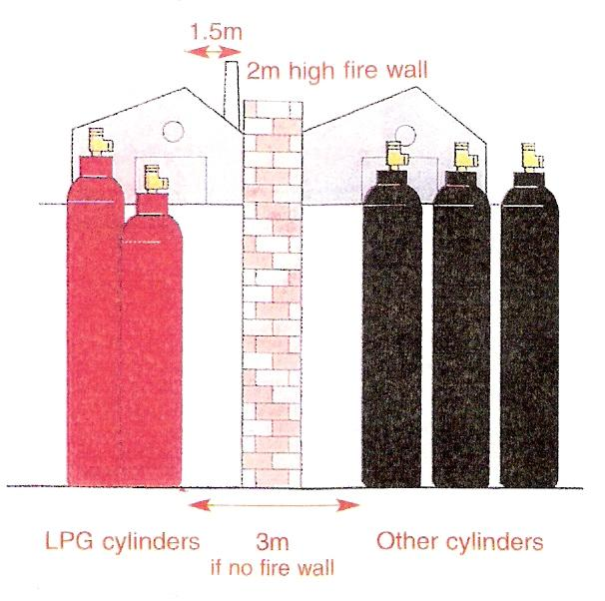
- store nothing else in the cylinder store as other materials may represent additional fuel sources if a fire starts.
This is especially applicable to oils, paints, thinners and other flammable or corrosive liquids.
- segregate full cylinders from empty cylinders.
- segregate cylinders according to potential hazards and type of gas i.e. oxygen, propane and very toxic.
- oxygen cylinders may be stored with cylinders containing inert gases.
- LPG cylinders must be stored 3m minimum away from any other gas cylinder type.
For detailed information see the LP Gas Association Code of Practice 7:1998
- pyrophoric and very toxic gases should be stored separately in locked, suitably ventilated storage areas with restricted access.

REMEMBER:
Know ALL the properties of the gases you deal with!

The location of the store is vital:
- the storage area should be preferably in open air, in a well ventilated place away from boundary fences.
- consideration must be given to segregation and location of storage areas with regard to the potential hazards of the gases stored. For example, heavier than air gases could seep into drains, ducts, and ventilation systems etc. Lighter than air gases could also enter buildings for example through air intakes.
- consideration must be given to access for delivery, manual handling and the emergency services - emergency services will want to 'shower' cylinders with water rather than direct a lot of water at them as the cylinder could be disturbed or even pushed over.
- ensure the storage area is away from potential sources of ignition and sources of heat.
- cylinders must be stored upright and secure on a clean, well drained level base.
- storage should be away from other processes and activities that may affect the cylinders.
- adequate lighting should be provided, potential ignition from artificial lighting should be a consideration.
- warning signs should include the types of gas stored, full and empty cylinders, no smoking, restricted access etc.
- security from vandalism, tampering and theft should be considered. Where necessary the use of 1.8m high industrial fencing may be necessary.
- gates, if locked for security, should not be fitted with self locking mechanisms and must open outwards. All emergency exits should be fitted with panic bars, be suitably identified and remain clear at all times.
- in addition to the above reference should be made to BCGA Guidance Note GN2.

REMEMBER:
A cylinder is never empty.

New Industrial Cylinder Identification Chart
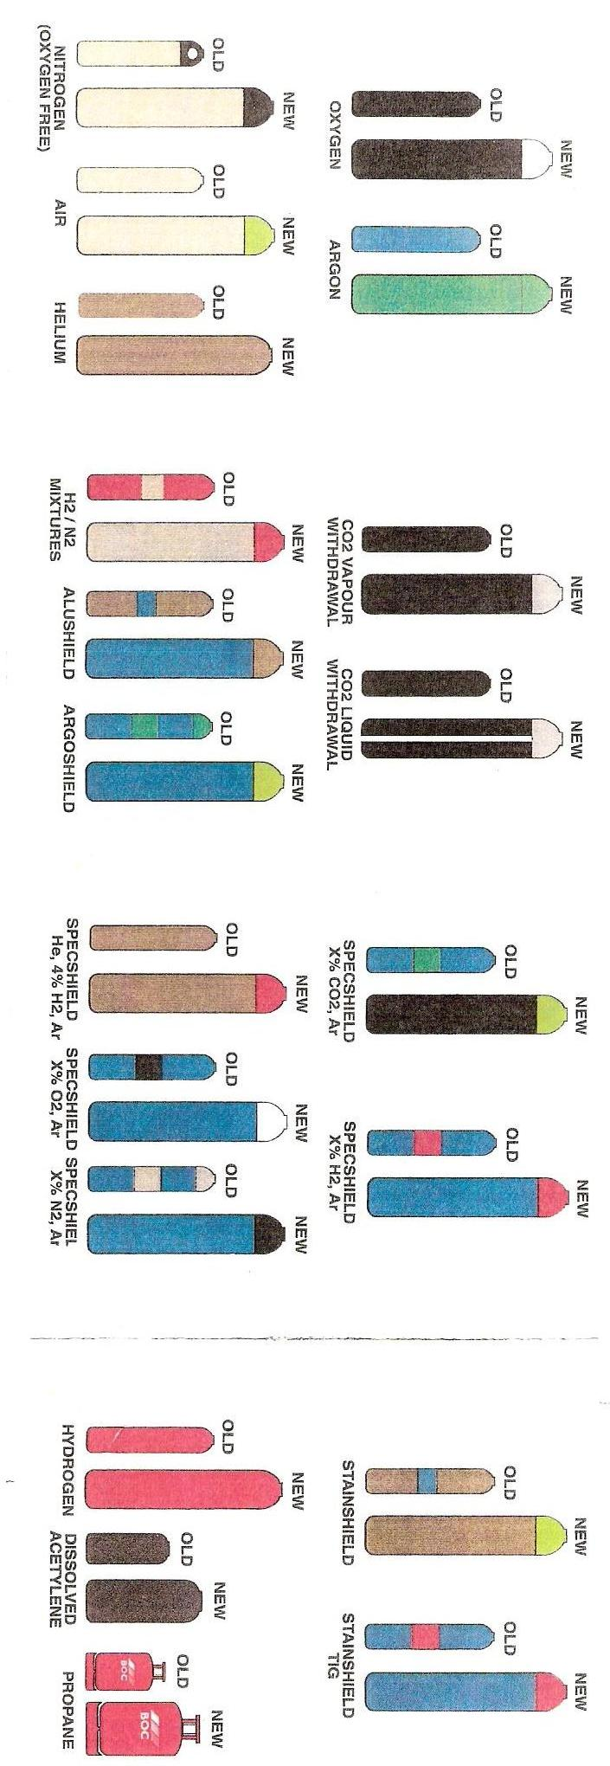

Equipment Assembly

Portable Oxy-Acetylene Welding and Cutting Equipment Assembly
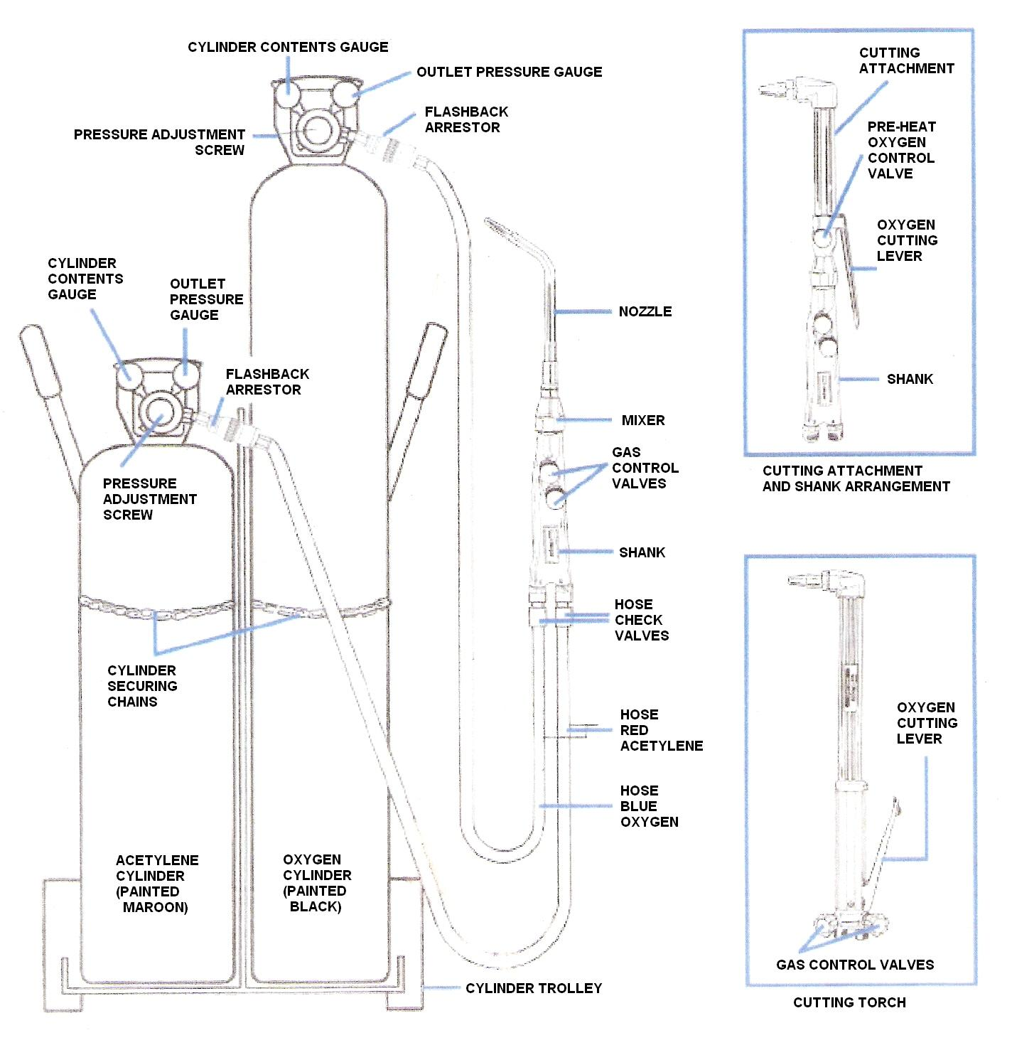
Figure 3 - Portable Oxy-Acetylene Welding and Cutting Equipment Assembly

The Oxy-Acetylene Flame
Acetylene is composed of Hydrogen and Carbon, as are most fuel gases. It is mainly the carbon which provides the intense heat and very high flame temperature (3100°C) when burned with oxygen. If sufficient oxygen is not provided, then the carbon is given off into the air as black, sooty smuts.

Acetylene has a very high proportion of carbon in it and if the oxygen is turned down to provide a flame with excess carbon, the carbon is taken into the steel to provide a high carbon surface, used for hard surfacing operations.
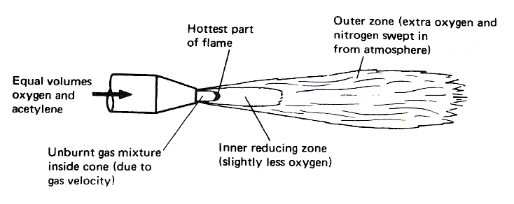
Figure 4 - Oxy-Acetylene Flame Showing the Various Zones

A neutral oxy-acetylene flame burns equal proportions of oxygen and acetylene and is reducing in nature, thereby reducing any iron oxide to iron and taking up the oxygen; consequently there is no need to use a flux when welding steel. It should be noted that iron oxide is not refractory.

Welding Demonstration 2 - The Structure of the Oxy-Acetylene Flame
AIM To demonstrate the three oxy-acetylene flame settings.
EQUIPMENT Oxy-acetylene welding equipment, including goggles and flint lighter.
THEORY There are three distinct flame settings:

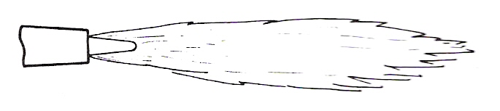
Figure 5 - Neutral Flame
Cone Tip Hottest Part Approx. 3100°C

- Neutral Flame
This flame burns equal quantities of oxygen and acetylene. (In practice, it is advisable to have the slightest possible acetylene haze at the cone tip to begin with.)
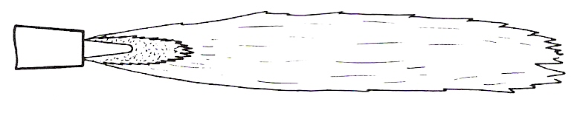
Figure 6 - Carburising Flame

- Carburising Flame
This flame has an excess of acetylene which results in a carbon-rich zone extending around and beyond the cone.
Note: Both the Neutral and Carburising flames are reducing in nature.
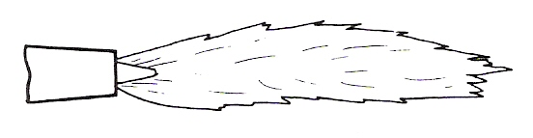
Figure 7 - Oxidising Flame

- Oxidising Flame
This flame has an excess of oxygen which results in an oxygen-rich zone just beyond the cone. This flame is obtained by setting to neutral and then turning the fuel gas down.

Flame Cutting Procedure
During many manufacturing processes it is often necessary to cut metals to size or to shape their edges with a bevel ready for welding. This chapter describes the various processes that can be employed for this purpose.

Operations Involved in Cutting
There are two operations involved in oxy-fuel cutting.
Heating flames are directed on to the metal to be cut, until it is raised to a bright red heat. This is called the ignition temperature, about 900°C.
A stream of high-pressure oxygen is directed on to the hot metal. This immediately oxidises the metal and, as the melting point of this oxide is below the melting point of steel, the oxide is melted and blown away.
The metal is therefore cut by a chemical action; the iron or steel is not melted. The heat needed to keep the cut going is provided partly by the heating jets and partly by the chemical action.

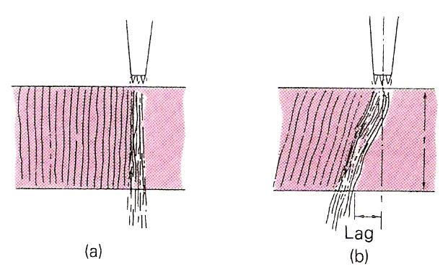
Figure 8 - Drag Lines on Cut Plate

- Vertical lines – zero drag
- Drag measured against plate thickness
– for example, 10% drag means a lag of 10% plate thickness.

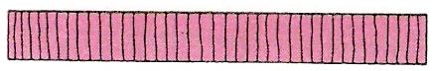 | Good cut.  Sharp top and bottom edges.  Vertical drag lines.  No adhering dross.  Square face. Light, easily removed oxide scale.
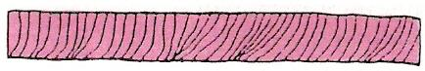 | Cutting speed too fast.  Top edge not sharp.  Rounded bottom edge, which may not be completely severed.  Drag lines uneven, sloping backwards.  Irregular cut edge.
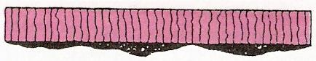 | Cutting speed too slow.  Rounded and melted top edge.  Bottom edge rough. Dross on bottom edge difficult to remove.  Lower part of cut face irregularly gouged.  Heavy scale on cut face.
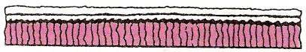 | Nozzle too high.  Excessive melting of top edge.  Undercut at top of cut face.
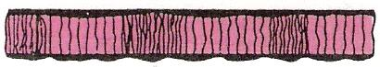 | Irregular cutting speed.  Wavy cut edge. Uneven drag lines.
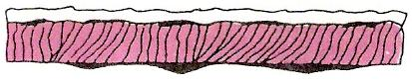 | Preheating flame too high.  Rounded top edge. Irregular cut edge. Melted metal falling into kerf.  Excessive amount of dross adhering strongly to bottom edge.
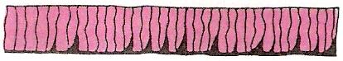 | Preheating flame too low.  Bad gouging of lower part of cut face.  Cutting speed slow.
Table 1 - Examination of Flame-Cut Edges
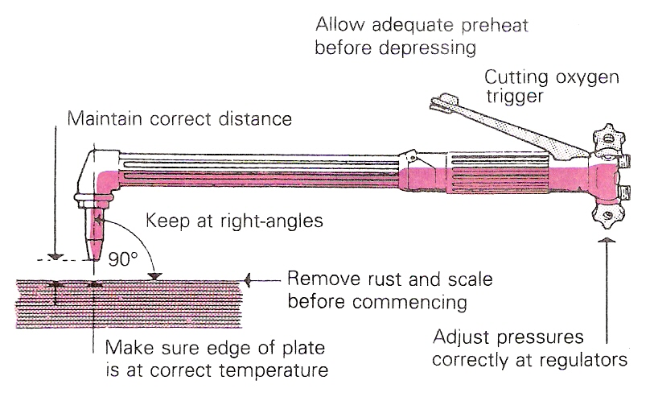
Figure 9 - Some tips for achieving a good cut

Blowpipes are usually of the injector type, so that they can be used on both high- and low-pressure systems. The modern type of cutting nozzle has the mixing chamber incorporated in it, so that a 'blowback' usually only goes as far as the nozzle; the high velocity of the gas tends to prevent it from going any further.
The size of the cutting blowpipe varies with the thickness of work; special heavy-duty blowpipes are available. Nozzle sizes also vary to suit different thicknesses of plate.
Cutting machines, in which one or several cutting blowpipes can be employed, are faster and more accurate than hand cutting.
Because cutting is essentially an oxidising process, little or no steel is melted. The kerf (the width of cut) should therefore be quite clean, and the top and bottom edges should be square. On examining melted oxides after cutting, it has been found that they contain up to 30 per cent unmelted steel, which has been scoured from the sides of the cut by the high-pressure oxygen stream. This scouring can be seen if the sides of the kerf are inspected, because drag lines will be faintly etched on the faces of the metal. For an incorrect cut, these drag lines will be more pronounced (Figure 8 and Table 1).
Figure 9 shows some tips for achieving a good cut.

Oxy-Fuel Gas Cutting by Hand
It takes a fair amount of skill to maintain a constant rate of travel over the work (Figure 10). The general quality of cut produced with a hand-held cutting torch is therefore usually inferior to the quality of cut made with a correctly adjusted cutting machine.
Cutting guides can help to keep the torch on the correct line of cut. A roller attachment can be used to maintain the correct nozzle-to-work distance.
Stack cutting can be used to cut more than one plate at once, if the same shape is required (Figure 11).

Oxy-Fuel Gas Cutting by Machine
Modern cutting machines are capable of making high-quality cuts within close limits. Many machines prepare bevelled edges for welding without any additional dressing operations being required.
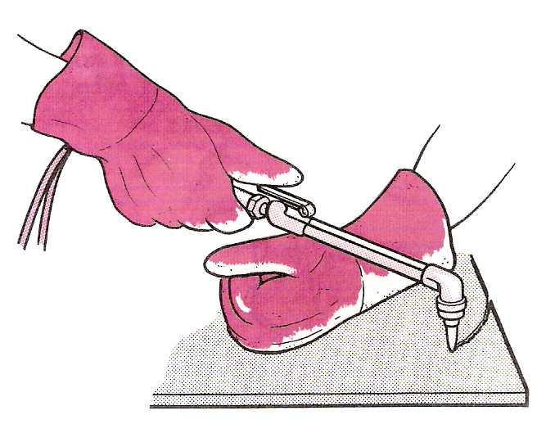
Figure 10 - Oxy-fuel Gas Cutting Freehand

This can be made much easier by the use of guides and attachments (see Figure 11).
There are many different designs of cutting machine. Some machines have a single cutting torch, while others have many. One design moves the cutting torch or torches above the plate to be cut, while another design keeps the cutting head stationary and moves the work beneath it.
The simplest cutting machine is the straight-line type, which consists of a carriage, mounted on a track, containing the cutting torch. The carriage is traversed over the work by a variable-speed electric motor (Figure 12).
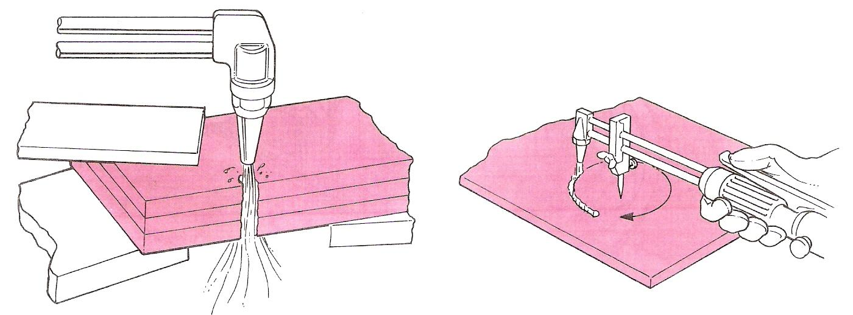
Figure 11 - Stack Cutting

It is possible to cut a stack of plates if they are clamped tightly together.
Cut a small circle using a small circle guide. Maintain the pivot point in the centre punch mark.

Profile Machine
Other machines, often called profiling machines, can guide the cutting head or heads by following a template. Some guiding systems have a magnetic wheel device that will follow the outline of a steel template, while others contain a photo-electric cell that will follow the black outline of a drawing.

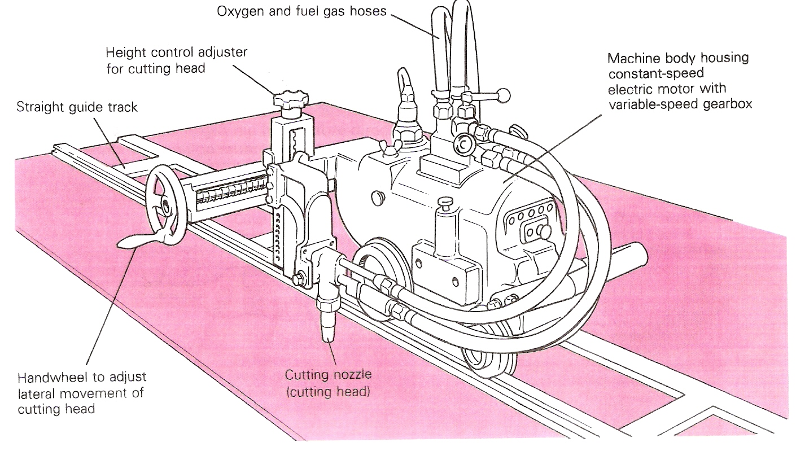
Figure 12 - Typical Straight-Line and Circle-Cutting Machine

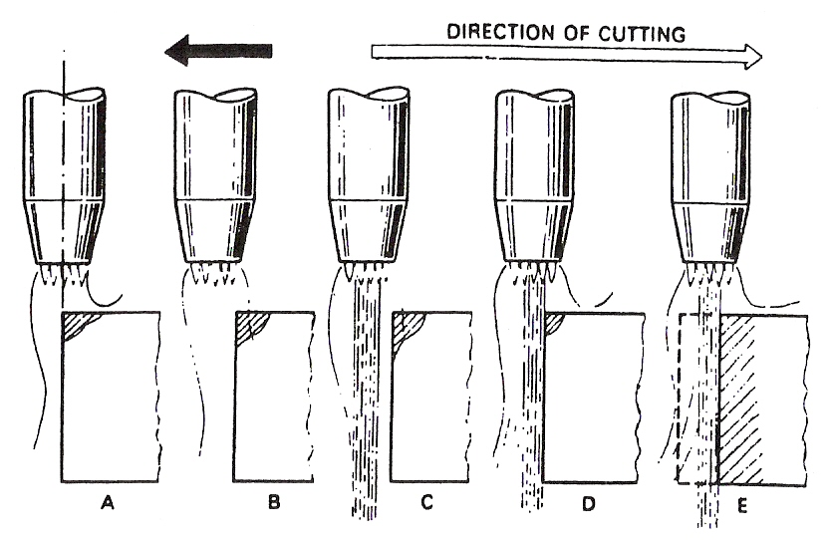
Figure 13 - Flame-cutting Procedure

A Pre-heat to ignition temperature
B Move the cutting torch backwards, just clear of edge
C Open the cutting oxygen valve
D Commence cutting
E Continue cutting

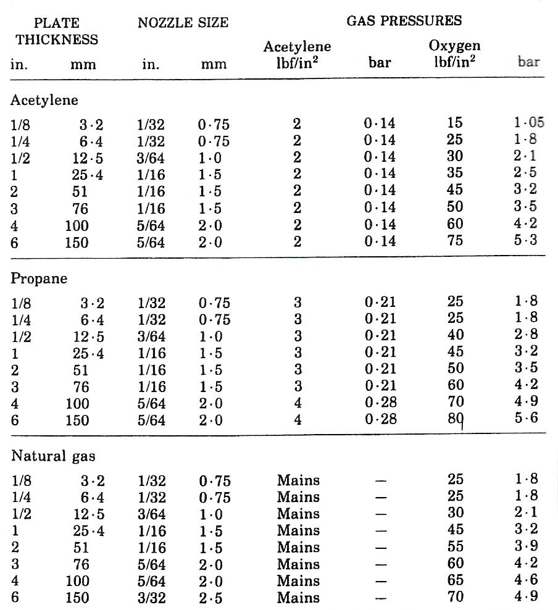
Table 2 - Approximate Pressures for Hand Cutting Steel Plate

Note:
The above figures are given only as a guide since the actual requirements may vary according to the nature of the work.
Some pressure regulators are fitted with gauges which are calibrated in kg/cm². 1 kg/cm² is approximately equal to 1 bar.

Cutting Nozzles
The cutting torch nozzles are so designed that they have a central port around which is either an annulus or several smaller ports. The smaller ports are circular holes in the case of acetylene cutting nozzles, and take the form of annular slots for propane. Through the smaller ports is fed the fuel gas mixed with the correct proportion of oxygen for the purpose of pre-heating the metal. The central port of orifice through which the main jet of oxygen is released will vary in diameter according to the size of the cutting nozzle required. The orifice diameter is increased as the thickness of the plate to be cut is increased – in general, a particular size of nozzle is used to cut a small range of thicknesses.

Figure 14 gives details of typical cutting nozzles.

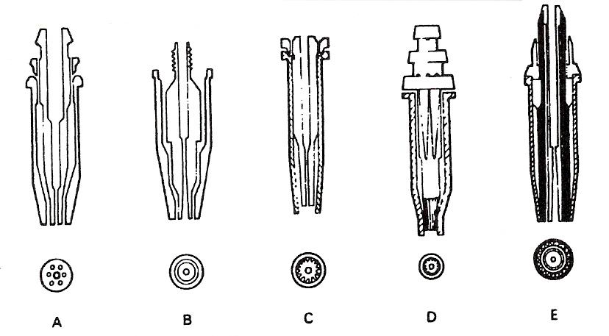
Figure 14 - Cutting Nozzle Design Feature

A One-piece ACETYLENE cutting nozzle – parallel bore, 3-9 pre-heat holes, no skirt.
B Two-piece ACETYLENE cutting nozzle – venturi bore, pre-heat annulus, no skirt.
C Two-piece NATURAL GAS nozzle-venturi bore, pre-heat flutes, long skirt.
D Two-piece PROPANE nozzle – parallel bore, pre-heat slots, long skirt.
E Two-piece PROPANE nozzle – parallel bore, pre-heat flutes, long skirt, oxygen curtain.

Circle-Cutting Device
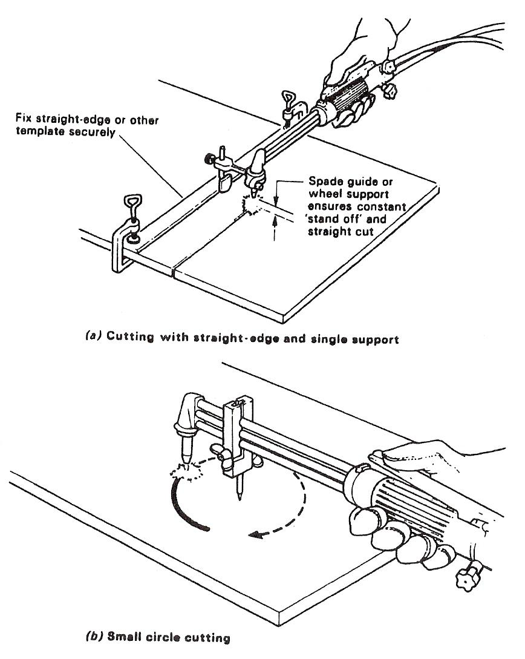
Basically there are three types of devices which may be used for radial cuts and circle cutting.

- Small circle-cutting attachment
This is simply a pivot which is attached to the shank of the torch at a particular distance from the nozzle according to the radius required. Such a device is illustrated in figure (b).
- Large circle-cutting attachment
This extremely useful device is illustrated in figure (c).
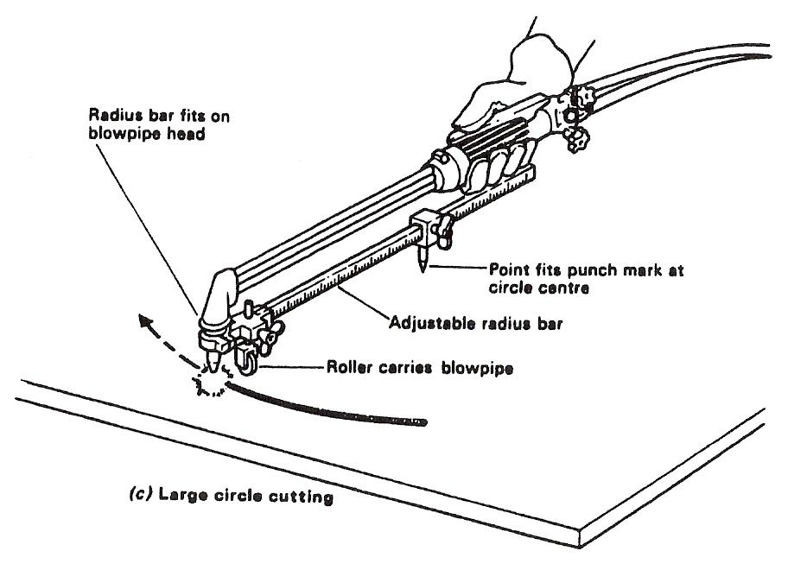
- Special cutting device for small holes
Some cutting torches are supplied in kit form and include a specially designed interchangeable shank in which the cutting head is ‘in line’ instead of being at the normal 90°. This special head is used in conjunction with a pivot for cutting small holes.

Attachments

Spade Guide
This is provided with vertical adjustment to obtain correct nozzle to plate distance. The support rides on the plate to be cut and may be pressed against a straight edge.
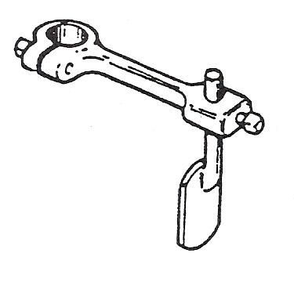
Figure 15 - Spade Guide

Small Circle Guide
Small circles may be cut by clamping a pivot on to the gas tubes of the blowpipe.
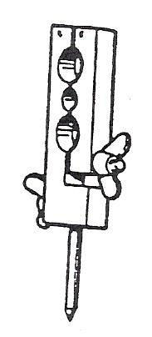
Figure 16 - Small Circle Guide

Radius Bar
Used for large circles. It is fitted with a wheel support and an adjustable pivot.

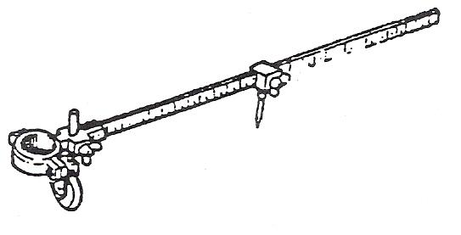
Figure 17 - Radius Bar

Bevel Guide
Bevel cutting may be obtained by either setting the wheels of the double support at different levels or by using the slotted clamping attachments.

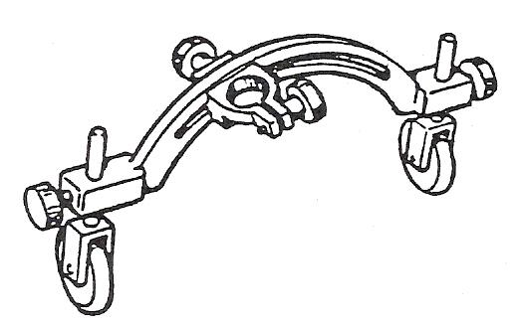
Figure 18 - Bevel Guide

Cutting Techniques

General
Assemble the equipment and arrange the material to be cut in a convenient position; faster cutting and a smoother finish is possible if rust and scale are removed from the path of the cut. Light up the nozzle and hold the blowpipe with the nozzle at right angles to the plate and apply the heating name to the edge of the material furthest from the operator. A spade or roller guide attached to the nozzle is of assistance in holding the blowpipe steady, so increasing the speed of cutting.
When the edge of the metal attains a bright red heat, operate the cutting oxygen lever and draw the blowpipe towards the operator's body along the line of cut at a speed recommended in the data tables.
The above remarks apply to cutting mild steel plate of normal thicknesses. The following points should be noted for differing cutting requirements.
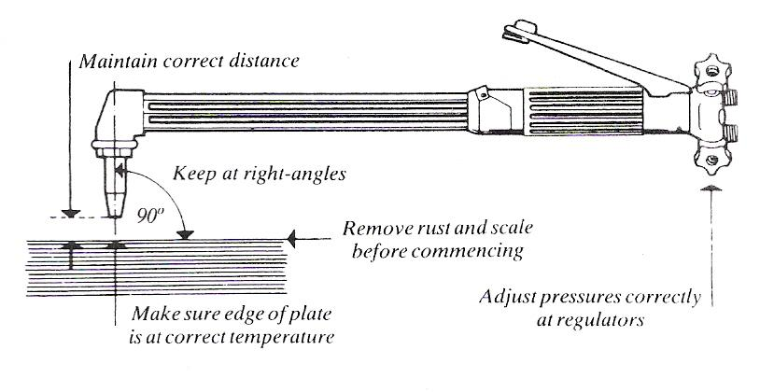
Figure 19 - Cutting Techniques

Thick Material
Because of the heavy gas consumption when cutting thick material, ensure that there is "an adequate supply of fuel gas and use a battery of oxygen cylinders coupled together or pipeline supplies. On very thick material, heat metal to bright red heat, operate the cutting lever, wait until the cutting reaction is seen to be right through the metal thickness to the bottom edge, and then draw the blowpipe along.

Painted and Galvanised Material
Clean the surface before starting to cut. It is often an advantage to incline the tip of the nozzle a little to help to undercut paint or scale. Unless ventilation is very good fume extraction should be installed at the point of cutting. In some cases it may be necessary to use a respirator as well.

Flame Cutting
Of all the methods used for material removal in the fabrication industry, the flame-cutting process plays a prominent part in the preparation of mild-steel plate material for welded fabrications. It is readily applicable to very large thicknesses of material and allows a multiplicity of shapes or contours to be cut - two points which restrict the use of guillotines.
It is faster than machining operations, which is an important advantage in connection with plate edge preparations for welded joints.
Most metals oxidise. The rate of oxidation in air depends upon the type of material and the temperature. The properties of the oxides formed are different from that of the parent metal.
Oxygen combining with a metal at a slow rate, as in the case of the rusting of iron, is referred to as 'OXIDATION', whereas if the formation of the oxide is very rapid, it is referred to as 'COMBUSTION' or 'BURNING'.
Generally, a rise in temperature of the metal has the effect of accelerating the rate of oxidation. In the case of mild steel when heated at a temperature of 890°C (bright cherry red), complete combustion takes place if it is in any atmosphere of pure oxygen, and a magnetic oxide of iron is formed.

The Process
Flame cutting is made possible by the fact that:
- IRON BURNS IN PURE OXYGEN WHEN HEATING TO ITS 'IGNITION' TEMPERATURE (890°C).
- HEAT IS GIVEN OUT BY THE EXOTHERMIC REACTION BETWEEN THE IRON AND OXYGEN.
Iron + Oxygen - Iron Oxide + Heat

The process consists of creating a local hot spot on the surface of the steel with a flame to ignition temperature and directing a high pressure jet of pure oxygen on to this PRE-HEATED spot. A vigorous and rapid chemical reaction takes place, the steel burns and oxides are formed. The exothermic reaction produces a great deal more heat. This heat is sufficient to melt the oxides formed on the metal.
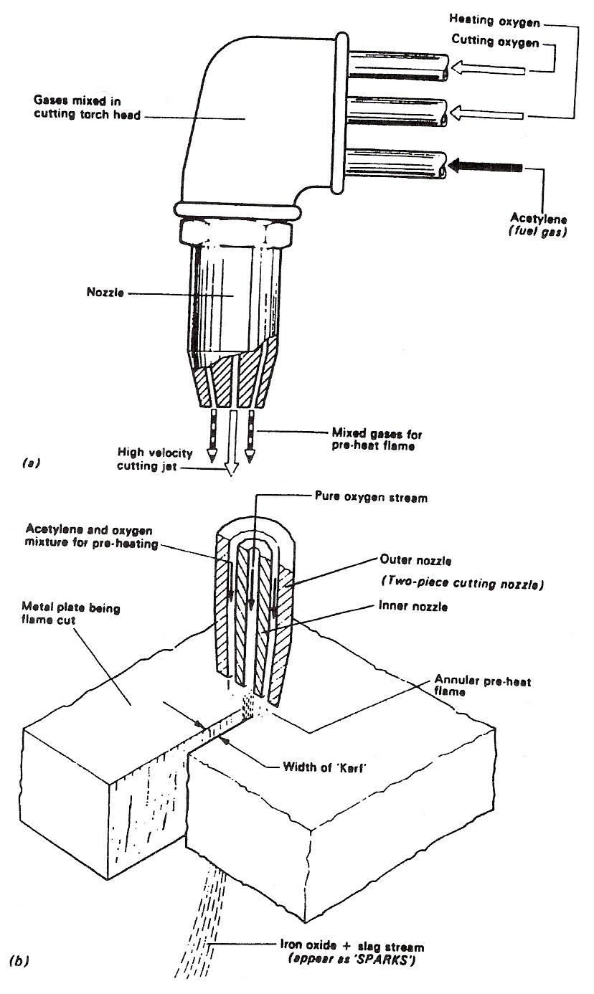
Figure 20 - The Action of Oxygen Cutting

Calculations for Straight Circular and Irregular Cuts
Allow 1 – 2 mm for the “kerf”.

The Pre-Heating Flame
The PRE-HEATING FLAME has a specific function:
To transmit sufficient heat to the surface of the steel to compensate for the heat loss due to thermal conductivity.
In this respect ACETYLENE, because of its high flame temperature, has the following advantages over PROPANE and Natural Gas.

Natural Gas
- Faster pre-heat starts.
- More able to penetrate priming, scale and rust.
- Provides for faster cutting speeds on thinner plate where the HEAT SPREAD across the plate is the controlling factor.

The disadvantage of the high-temperature acetylene preheat flame is the tendency for excessive melting of the top edges of the cut.
This is generally associated with the use of too large a pre-heating flame once the cut has started, and this problem may be eliminated by correct flame control and distance from the workpiece.
The pre-heating flame must be of sufficient intensity in order to break up surface scale and to maintain the steel at ignition temperature irrespective of surface irregularities.
Only those materials whose combustion or ignition temperature is below their melting point can be flame cut. Otherwise the material would melt away before OXIDATION could take place, making it impossible to obtain a cleanly cut edge.
NON-FERROUS METALS CANNOT NORMALLY BE FLAME CUT. Cast iron and stainless steel require special procedures and even then a 'flame-cut edge' of the same quality as with plain carbon steel is difficult to obtain.

Types of Cut

Correct Cutting
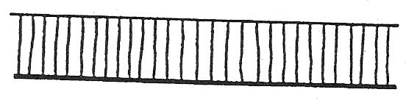
Sharp top edge.
Almost vertical lines.
Square face with light slag.
Good bottom edge.

Cutting Speed Too Slow
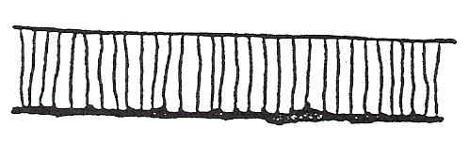
Melted and rounded top edge.
Lower part of cut face gorged irregularly.
Bottom edge rough.
Heavy scale on cut face.
Heavy dross on underside difficult to remove.

Cutting Speed Too Fast
Top edge not sharp and may be undercut.
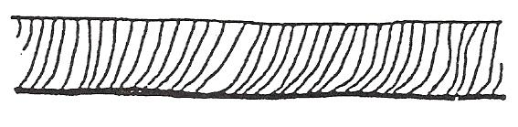
Drag lines very marked and uneven sloping backwards.
Irregular cut edge.
Slightly rounded bottom edge which may not be completely severed.

Self Assessment

Questions on Background Notes – Module 2.Unit 1

1. In relation to Gas used in Industry – Oxygen / Acetylene / Argoshield etc.
Name two important characteristics of different Gases.

2. Give one example of an Inert Gas and one example of a Flammable Gas.

- What is the correct way to store cylinders whether in use or in storage?

4. What Colour Bottle is:
a. Pure Argon
b. Acetylene
c. Oxygen
d. Argoshield

5. What temperature does the Oxygen / Acetylene flame burn at?

6. What does the term ‘Stack Cutting’ mean?

7. When cutting Painted and Galvanised material, what steps should be taken?

8. What is the pressure in Oxygen / Acetylene Cylinders?

9. Why should you never Grease / Lubricate Oxygen Equipment.

10. What is a Flashback Arrestor?

Answers to Questions 1-10. Module 2. Unit 1
1.

a. The density of the Gas. If there was a leak the gas will either
rise or fall as some gases are lighter or heavier than others.

b. Most Gases are colourless and odourless in their natural state
so there is little or no warning of a leak.

c. All fuel Gases have a left - hand thread on all connecting
parts.

2.

Inert Gas:

Nitrogen, Argonsheild and Helium based mixtures.

Flammable Gas:

Acetylene, Hydrogen and Propane.

3.

a. In a secured upright position. Stored in a well ventilated and
secure compound.

b. Ensure storage has adequate warning signs.

c. Store cylinders in a designated ‘No Smoking Area’ away from
fire risk, heat and a source of ignition.

d. Segregate full cylinders from empty cylinders.

4.

a. Green

b. Maroon / Wine colour

c. Black with White collar

d. Blue with Green collar

5.

3100° c approx.

6.

The Oxygen / Fuel Gas cutting method:

Where plates are stacked 3 and 4 together, but must be tightly
clamped.

7.

Clean surface before starting to cut. Plenty of ventilation / fume
extraction and breathing apparatus.

8.

Oxygen: 230 bar @ 15°c

Acetylene: 15.5 bar @ 15°c

9.

Oxygen Equipment is at most risk from oil and grease. High
pressure Oxygen will react violently with oils and grease, it may
explode or ignite violently.
Even PTFE Tape contains traces of oil and should not be used to
seal joints.

10.

A Flashback Arrestor is a device designed to quench flames
that may travel into the cylinders through the hose, this is
known as a ‘Flashback’.

Index

A
Attachments, 35
Bevel Guide, 36
Radius Bar, 36
Small Circle Guide, 35
Spade Guide, 35
C
Calculations for Straight Circular and Irregular Cuts, 40
Circle-Cutting Device, 34
Cutting Nozzles, 33
Cutting Techniques, 37
General, 37
Painted and Galvanised Material, 37
Thick Material, 37
Cylinder Safety Advice
Safe Storage of Cylinders, 15
Safe Transport of Cylinders, 15
E
Equipment Assembly, 23
Portable Oxy-Acetylene Welding and Cutting Equipment Assembly, 23
F
Flame Cutting, 38
The Process, 38
Flame Cutting Procedure, 26
Operations Involved in Cutting, 26
Oxy-Fuel Gas Cutting by Hand, 28
Oxy-Fuel Gas Cutting by Machine, 29
Profile Machine, 30
G
Gas Characteristics, 11
Gas Cylinders, 16
N
Natural Gas, 40
New Industrial Cylinder Identification Chart, 22
O
Operating Techniques, 10
S
Safe Storage of Gas Cylinders, 18
Safety in Cylinder Handling, 13
T
The Oxy-Acetylene Flame, 24
Welding Demonstration 2 - The Structure of the Oxy-Acetylene Flame, 25
The Pre-Heating Flame, 40
Types of Cut, 41
Correct Cutting, 41
Cutting Speed Too Fast, 41
Cutting Speed Too Slow, 41

